My Accutrack License is Expired

Installing a Generated Accutrack Serial Number

The Accutrack serial number controls which modules are available and the number of simultaneous users that may login to the software. The serial number is programmed into the dongle and is installed into the registry. If you do not have a working dongle, you can install a generated serial number instead.
Dongles never expire. Generated serial numbers have an expiration date. So if you are installing a generated serial number, when it expires in the future you will have to contact ABC Sign Products to receive a replacement serial number.

You will typically see the error message “Your license is expired,” or “Your license will expire in x days” when you try to login to Accutrack.

A generated serial number will look like this:
3819264759OHG5430751424244
There are 3 or 4 capital letters in the center. In this case O,H,G. That is a capital O, not a zero and must be entered correctly.

Not Yet Expired

If your license is not yet expired, login to Accutrack and go to Help\About Estimate

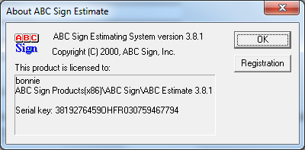

Click on Registration

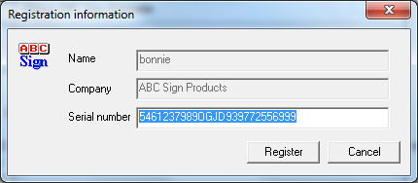

Type or copy the new serial number into place and click Register.

Input into Registry

If your license is already expired, you will not be able to login to Accutrack to access the registration screen. You must input the license number into the Windows Registry.

Click on your start button and type regedit.

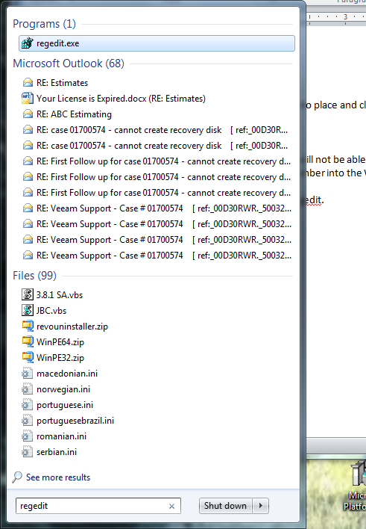

Start regedit.exe
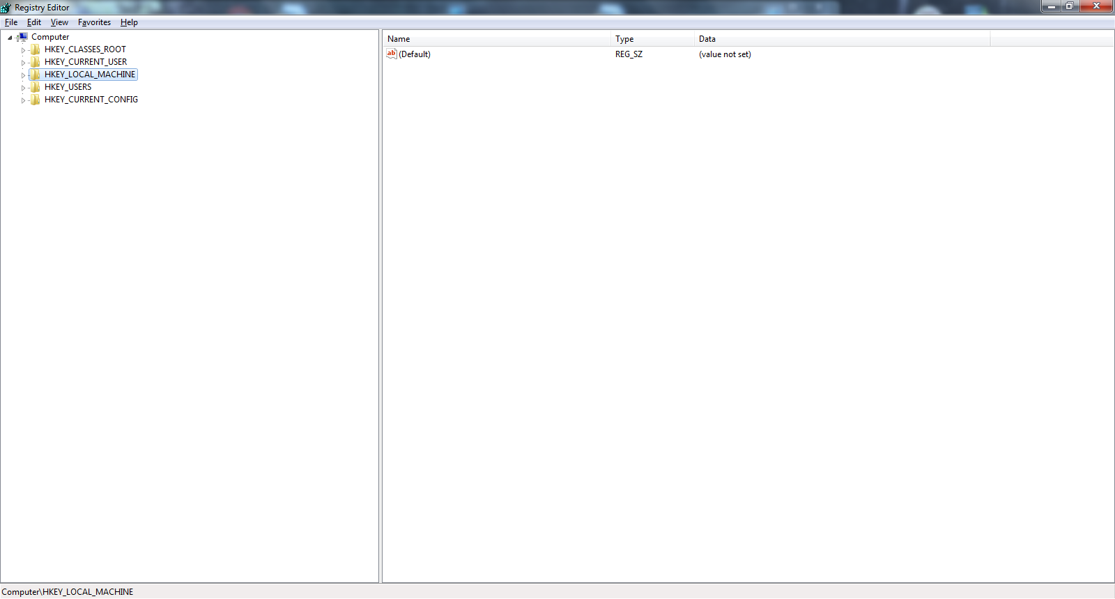

Expand HKEY_LOCAL_MACHINE

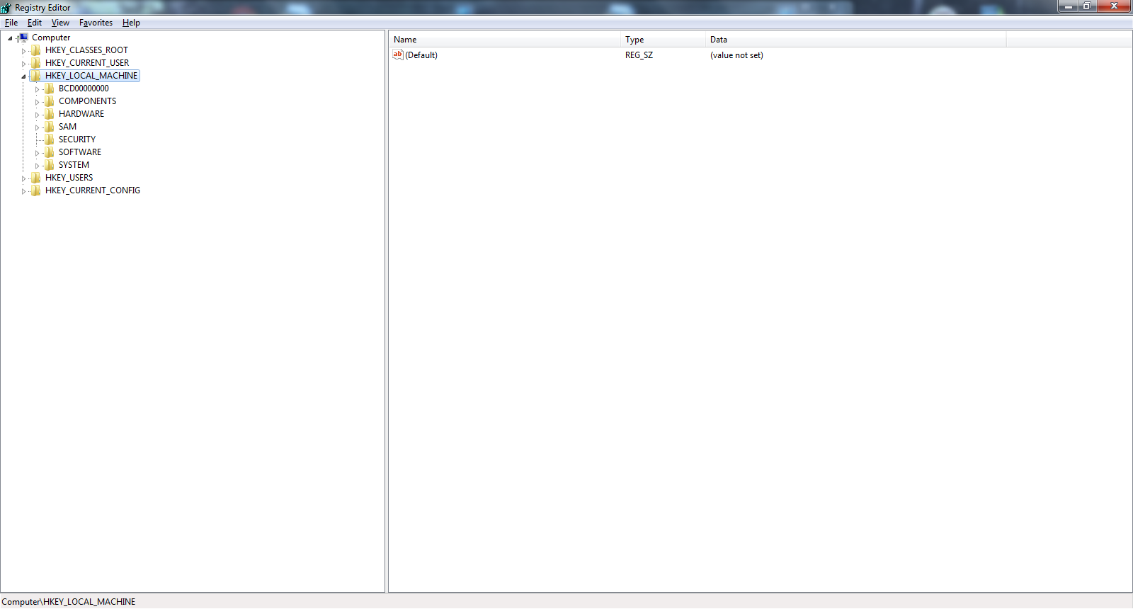

Expand Software

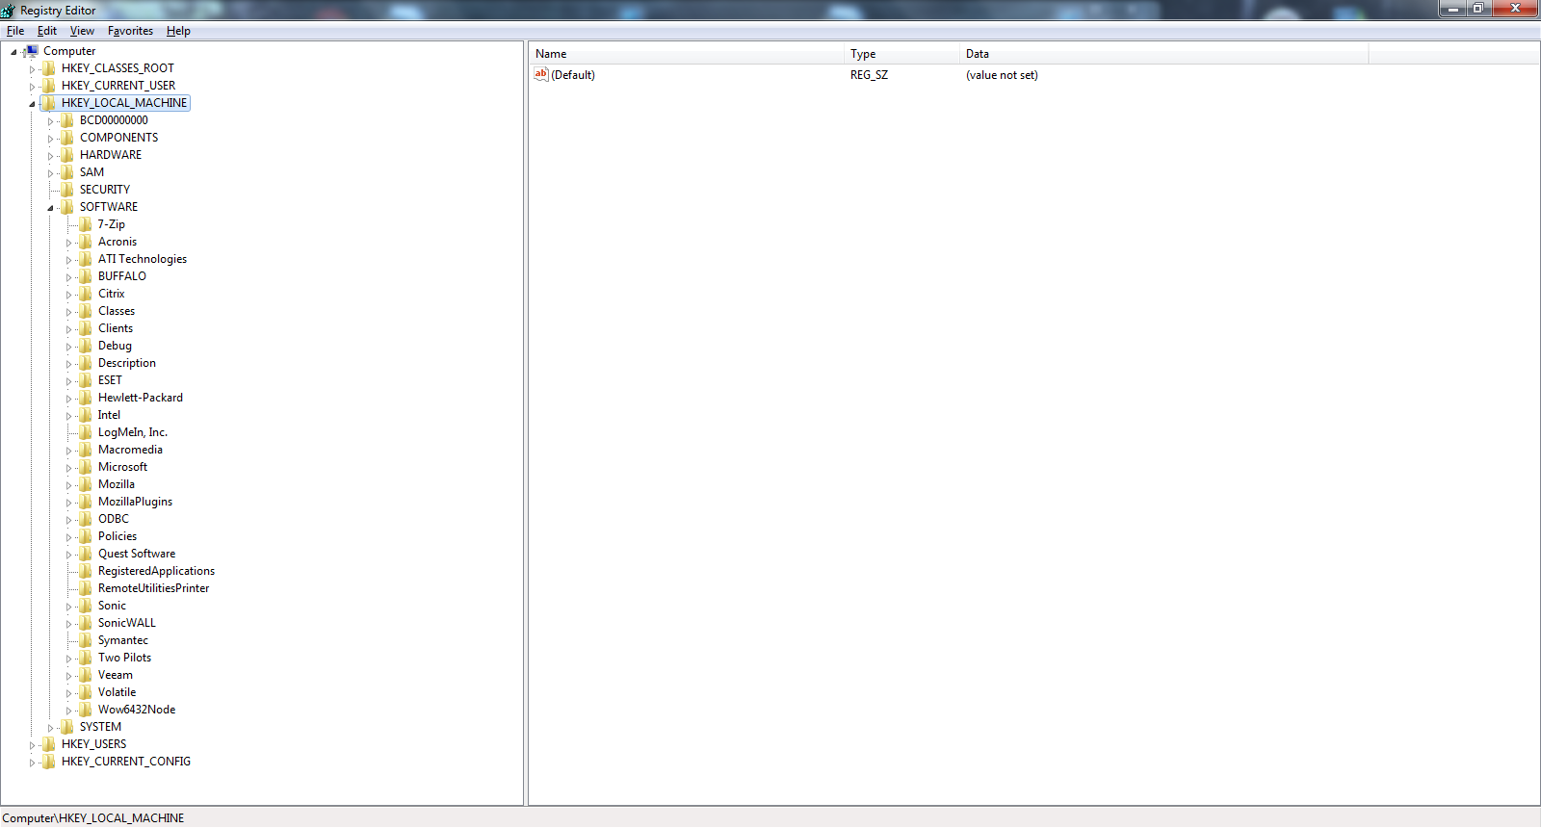

Expand Wow6432 Node

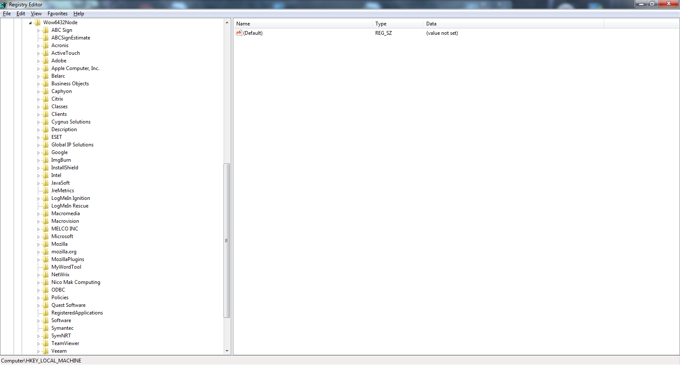

Click on ABC Sign Estimate

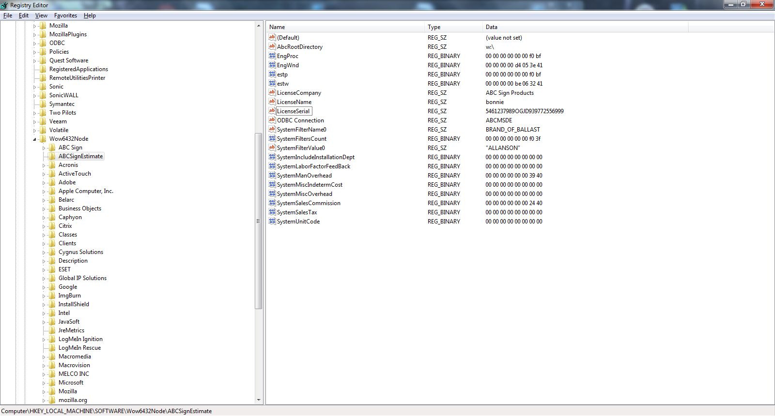

On the right screen double-click LicenseSerial

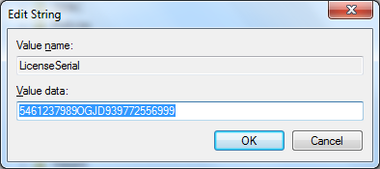

Input the new serial number. Click OK and Exit the Registry.

Start Accutrack and you should now be able to login.

